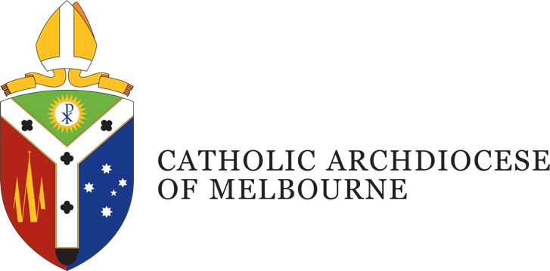

Position Description
Title: Discipleship Specialist – Young Adults
Department: Proclaim - Discipleship
Location: East Melbourne
Employment Status: Permanent, full time
Reports to: Discipleship Coordinator
Number of direct reports: Nil

Position Purpose
The Discipleship Specialist – Young Adults, will have specialised expertise in the area of young adult ministry within the Proclaim team in carrying out the support, formation and resourcing of Catholic communities across the Archdiocese of Melbourne toward a more missionary orientation. Recognising that programs do not make disciples - people do. discipleship is primarily about developing the capacity of leaders within Catholic communities to develop relationships that are intentional, personal and structured.

Department Overview
Proclaim: Office for Mission Renewal was established in early 2020 to support the life of the Archdiocese of Melbourne in our aim to strive for ‘the missionary option’ in all we do. In responding to this call, we heed Pope Francis’ words in Evangelii Gaudium to seek 'a missionary impulse capable of transforming everything, so that the Church’s customs, ways of doing things, times and schedules, language and structures can be suitably channelled for the evangelisation of today’s world'. (§27)
The Proclaim team is at the service of parish communities within the Archdiocese, offering strategies, resources and support. The team is divided into three domain areas that direct our efforts, Animation, Discipleship, and Formation.
The Discipleship Team operate as a dynamic team to build a culture of discipleship in parishes, communities and on campuses within the Archdiocese of Melbourne to develop programs and opportunities for deeper engagement with marriage, family, youth, young adults, and university students.

Organisational Description
Presided over by the Archbishop of Melbourne, the Archdiocese comprises around 1.1 million Catholics, and is the largest Archdiocese in Australia with a wide variety of people, cultures and ministries, providing services and support including pastoral, educational, social welfare and administrative support.
Under the guidance of four key priorities outlined by the Archbishop, the works and activities of the Archdiocese are oriented towards a missionary focus to address the ongoing needs of: Local Communities; Families; Youth and Young Adults; and the Poor and the Broken.
This is achieved through a pro-active engagement in the sharing of Mission; a reaching out in Gospel boldness; operating in an agile and responsive mindset; identifying and embracing what is fruit bearing in our works; understanding the outward focus and call of being missionary disciples; and being mindful of good stewarding in terms of time, talent and gifts.

Key Accountabilities
- Develop resources, training, and facilitate initiatives that support young adult discipleship to be implemented within a parish or local community context.
- Develop capacity in local communities to initiate, continue or expand their ability to implement models, programs or resources for young adults in their context.
- Support parishes and communities in their engagement with and outreach to young adults to instil a proactive engagement in the sharing of Mission and outreach;
- Support the identification and encouragement of local missionary leaders involved in young adult ministry, to be effective missionary disciples who are instrumental in the Church’s missionary transformation and ecclesial renewal to build a network of discipleship animators throughout the Archdiocese of Melbourne;
- Provide expertise and support to the Animation Team members on the area of young adult discipleship within a parish or local community context
- Explore and create models, resources, training and other supports for understanding and effecting a contemporary model of young adult discipleship in a variety of local contexts and communities to enable and equip local faith leaders to drive towards an outward missionary orientation;
- Display a consistent mindset of agility, adaptation, innovation and continuous improvement by identifying ways to ensure the needs of parishes, communities and other stakeholders of the Archdiocese – in the specialist ministry to young adults - are being met in a changing and secular environment
- Engage and build strong relationships with leaders in Parishes and communities where young adults seek community throughout the Archdiocese to build relationships of trust that enable openness to new ideas and a call into new frontiers of mission;
- The Archdiocese may require you to undertake other duties from time to time commensurate with your qualifications, knowledge, experience and ability.
- Takes reasonable care to protect the health and safety of themselves, fellow staff and others in the workplace.

Job Competencies – (skills)
- Well-developed issue management and problem solving skills
- Exceptional communication skills with proven capability to network, present to, and influence individuals, community groups, and meetings.
- Proficiency in successfully working on collaborative processes and practices that encourage team involvement and input.
- Exceptional resource and time management skills, delivering work efficiently and within agreed timelines.

Personal Competencies – (attributes)
- An extensive understanding of, and commitment to, the teachings of the Catholic Church and the philosophy and core values of the Catholic Archdiocese of Melbourne.
- Commitment to being adaptable and demonstrating flexibility and agility in the workplace, including a willingness to work variable hours (i.e., evenings and weekends).
- Ability to respond positively to challenging circumstances and a commitment to collaboratively finding solutions to challenging problems.
- High level of integrity, honesty and confidentiality, with an awareness and appreciation of Catholic Social Teaching.
- Sound time-management skills and ability to prioritise.
- Excellent interpersonal, verbal and written communication skills.
- Ability to work collaboratively within and across departments, agencies, ministries and parishes of the Catholic Archdiocese of Melbourne and its partners.

Key Selection Criteria
- Tertiary qualifications (or working towards) in theology, religious education, ministry, or a similar relevant discipline (desirable)
- Significant experience (3+ years) in a Church environment or discipleship ministry setting, with a focus on young adult ministry
- Current Victorian Driver’s Licence (essential)
- National Police Record Check (essential)
- Working with Children Check (essential)

Position Description Acknowledgement
By signing my contract, I acknowledge that I have received, reviewed and fully understand the position description for Discipleship Specialist – Young Adults. I further understand that I am responsible for the satisfactory execution of the essential functions described therein, under any and all conditions as described.

Employee Name: [insert name] Date: ______/______/_______

Employee Signature: _________________________________________

