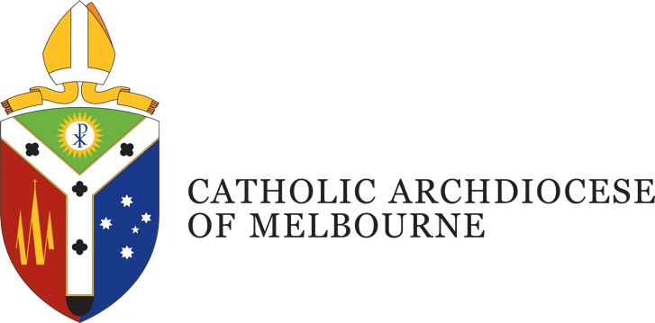

Position Description
Title: Development Operations Manager
Department: Development and Philanthropy
Location: St Patrick’s Centre, East Melbourne
Employment Status: Full Time
Reports to: Director, Development and Philanthropy
Number of direct reports: Two

Position Purpose
The Development Operations Manager is responsible for the coordination and operational leadership of the Archdiocese’s major fundraising and engagement programs. Working within the Development and Philanthropy Office, this role ensures that appeals, campaigns, and giving programs are strategically planned, insight-informed, operationally sound, and aligned with the Catholic mission.
This role brings together key functions—program delivery, donor experience, data systems, and community insights—to build a coherent and effective fundraising infrastructure across the Archdiocese. It also oversees a small delivery team and collaborates closely with internal stakeholders, external partners, and parishes.

Department Overview
The Development and Philanthropy Office of the Archdiocese of Melbourne was instituted by the Archbishop of Melbourne in 2022. The purpose of the department is to develop programs and foster relationships within the Catholic Community to support:
- Initiatives of the Archbishop of Melbourne
- The Parishes of the Archdiocese
- Catholic Agencies of the Archdiocese
The program calls upon the deep tradition of the Church and its theology to inform its approach to the various fundraising activities.

Organisational Description
Presided over by the Archbishop of Melbourne, the Archdiocese comprises around 1.1 million Catholics, and is the largest Archdiocese in Australia with a wide variety of people, cultures and ministries, providing services and support including pastoral, educational, social welfare and administrative support.
Under the guidance of four key priorities outlined by the Archbishop, the works and activities of the Archdiocese are oriented towards a missionary focus to address the ongoing needs of: Local Communities; Families; Youth and Young Adults; and the Poor and the Broken.
This is achieved through a pro-active engagement in the sharing of Mission; a reaching out in Gospel boldness; operating in an agile and responsive mindset; identifying and embracing what is fruit bearing in our works; understanding the outward focus and call of being missionary disciples; and being mindful of good stewarding in terms of time, talent and gifts.

Key Accountabilities
1. Fundraising Program Delivery
- Lead the operational delivery of major fundraising programs:
  - Annual Appeal
  - St Patrick’s Cathedral Capital Campaign (Light into the City)
  - Melbourne Catholic Professionals
  - Parish Offertory Giving Programs
- Coordinate the development and distribution of resources, parish kits, digital giving portals, and donor communications.
- Ensure campaigns are launched in a timely, professional, and mission-aligned manner.
2. Donor Engagement and Supporter Experience
- Design and manage digital donor journeys, segmentation strategies, and personalised outreach.
- Support the execution of appeals and donor communications in collaboration with the Communications team.
- Monitor feedback and data to continuously improve donor touchpoints.
3. Data, Systems, and Reporting
- Collaborate with the Fundraising Operations Manager to ensure the effective use of Raiser’s Edge CRM and related systems.
- Support data-driven decision-making by ensuring accurate gift processing, reporting, and donor analytics.
- Coordinate financial reconciliation processes and ensure donor data integrity.
4. Community Research and Strategic Integration
- Collaborate with the St Patrick’s Cathedral Campaign Manager to incorporate research into campaign planning, precinct engagement, and donor strategy.
- Ensure fundraising reflects the voice of the Catholic community and engages diverse groups, including parishes, schools, and migrant communities.
5. Team Leadership and Coordination
- Provide leadership and support to a cross-functional delivery team.
- Facilitate collaboration across the Development and Philanthropy Office and coordinate project delivery across campaigns.
6. Other
- The Archdiocese may require you to undertake other duties from time to time commensurate with your qualifications, knowledge, experience and ability.
- Takes reasonable care to protect the health and safety of themselves, fellow staff and others in the workplace.

Job Competencies – (skills)
- Proven ability to lead projects, manage teams, and coordinate multiple workstreams.
- Experience with CRM systems, particularly Raiser’s Edge or comparable donor databases.
- Ability to translate data and community insights into fundraising strategy.
- Familiarity with, or previous exposure to, donor journeys, giving platforms, and fundraising communications.
- Current understanding, or willingness to develop an understanding of, endowments, bequest programs, or capital campaign structures.
- National Police record and Working with Children Checks (essential).

Personal Competencies – (attributes)
- High level of integrity, honesty and confidentiality.
- Willingness to work in accordance with the mission, ethos, and teachings of the Catholic Church.
- Sound time-management skills and ability to prioritise.
- Excellent interpersonal, verbal and written communication skills.
- Ability to work collaboratively within and across departments, agencies, ministries and parishes of the Catholic Archdiocese of Melbourne and its partners.

Key Selection Criteria
Essential
- Minimum 5 years’ experience in a similar fundraising, campaign, or donor engagement role.
- Proven ability to lead projects, manage teams, and coordinate multiple workstreams.
- Experience with CRM systems, particularly Raiser’s Edge or comparable donor databases.
- Strong interpersonal, organisational, and communication skills.
- Ability to translate data and community insights into fundraising strategy.
- Commitment to the mission and values of the Catholic Church.
Desirable
- Experience in a diocesan, parish, or other faith-based context.
- Familiarity with donor journeys, giving platforms, and fundraising communications.
- Understanding of endowments, bequest programs, or capital campaign structures.
Workplace Requirements
- Occasional travel across the Archdiocese (e.g. to parishes or events) and some work outside regular hours may be required.

Position Description Acknowledgement
By signing my contract, I acknowledge that I have received, reviewed and fully understand the position description for Click or tap here to enter text. I further understand that I am responsible for the satisfactory execution of the essential functions described therein, under any and all conditions as described.
Employee Name: Click or tap here to enter text. Date: Click or tap to enter a date.

Employee Signature: _________________________________________

