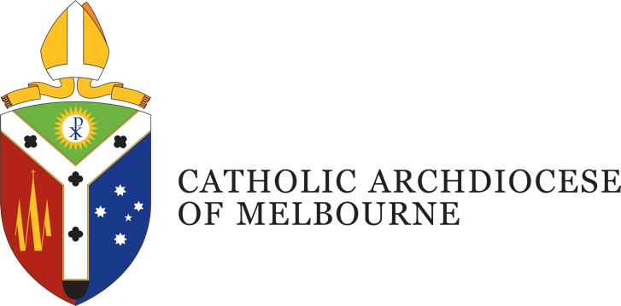

Position Description
Title: Digital Designer
Department: Proclaim – To Know, Worship and Love
Location: East Melbourne
Employment Status: Permanent, full time
Reports to: KWL Coordinator
Number of direct reports: Nil

Position Purpose
The Melbourne Archdiocesan Religious Education digital resource, “To Know, Worship & Love” (KWL), is undergoing a significant review and redevelopment. This includes not only revised and approved content but also a refreshed visual layout and design that enhances the presentation of key concepts and deepens engagement for both teachers and students.
Reporting to the KWL Coordinator, the Digital Designer will play a vital role in supporting the visual development of this major digital revision project. The role is designed to increase the Proclaim – To Know, Worship & Love office’s capacity to deliver a high volume of content, while also contributing diverse design skills to broaden the range and quality of content types produced.
The Digital Designer will engage closely with internal stakeholders including the Digital Content Manager, KWL Coordinator, and the broader Proclaim team, contributing to content development, reporting progress, and participating in strategic discussions. Externally, the role involves liaising with Religious Education Coordinators and Leaders (RECs/RELs) in Catholic schools, who are often the primary point of contact and responsible for the acquisition and implementation of KWL Digital resources in their schools.

Department Overview
Proclaim: Office for Mission Renewal was established in early 2020 to support the life of the Archdiocese of Melbourne in our aim to strive for ‘the missionary option’ in all we do. In responding to this call, we heed Pope Francis’ words in Evangelii Gaudium to seek 'a missionary impulse capable of transforming everything, so that the Church’s customs, ways of doing things, times and schedules, language and structures can be suitably channelled for the evangelisation of today’s world'. (§27)
The Proclaim team is at the service of parish communities within the Archdiocese, offering strategies, resources and support. The team is divided into three domain areas that direct our efforts:
Animation – focussed on parish renewal with a team of animation consultants who work directly in support of clergy and parish leadership teams. The animation team focus on growing communities of faith that are vital, vibrant and viable.
Discipleship – support our parishes to grow a culture of discipleship of encountering Jesus Christ, engaging more deeply in a life of faith, and embarking on mission with a particular focus on youth and young adults, campus ministry and family accompaniment.
Formation – equipping people to be formed and form others through the Bethany Way and including the development of formation resources that supports the life of our parishes.

Organisational Description
Presided over by the Archbishop of Melbourne, the Archdiocese comprises around 1.1 million Catholics, and is the largest Archdiocese in Australia with a wide variety of people, cultures and ministries, providing services and support including pastoral, educational, social welfare and administrative support.
Under the guidance of four key priorities outlined by the Archbishop, the works and activities of the Archdiocese are oriented towards a missionary focus to address the ongoing needs of: Local Communities; Families; Youth and Young Adults; and the Poor and the Broken.
This is achieved through a pro-active engagement in the sharing of Mission; a reaching out in Gospel boldness; operating in an agile and responsive mindset; identifying and embracing what is fruit bearing in our works; understanding the outward focus and call of being missionary disciples; and being mindful of good stewarding in terms of time, talent and gifts.

Key Accountabilities
- Work collaboratively with content (text) contributors to design visual concepts and mechanics to create effective and visually engaging Religious Education (Digital) learning objects.
- Conceptualise written content from text contributors or existing products for the creation of drafts, storyboards or prototypes.
- Creation and modification of static and interactive digital content assets.
- Collaborate with the members of the team on the mechanics of new assets such as templates, interactive content and Religious Education (Digital) learning objects.
- Front-end Development of static and interactive digital content, User Interfaces and Religious Education (Digital) learning objects.
- Learning and adapting to new web design methods and trends in relation to business products and evolving technologies
- The Archdiocese may require you to undertake other duties from time to time commensurate with your qualifications, knowledge, experience and ability.
- Takes reasonable care to protect the health and safety of themselves, fellow staff and others in the workplace.

Job Competencies – (skills)
- Advanced knowledge & experience of Adobe Creative Suite, with ability to articulate and formally present creative concepts as well as finished products for a variety of platforms.
- Ability to produce Motion Graphics with a working understanding of animation principles, colour, form, composition, timing and layout.
- Working knowledge of HTML, CSS, JavaScript/ JS libraries, CMS principles and version control systems with the capability of developing for cross-browser environments and creating responsive web content.
- Experience with front-end development, using a variety of frameworks with a working knowledge of relevant extensions and plug-ins.
- Knowledge of UI design with the ability to implement best practices and principles
- National Police record and Working with Children Checks (essential)

Personal Competencies – (attributes)
- Ability to research, learn and implement new and emerging technologies.
- High level of integrity, honesty and confidentiality, with an awareness and appreciation of Catholic Social Teaching.
- Possess high problem solving and analytical skills.
- Sound time-management skills and ability to prioritise.
- Excellent interpersonal, verbal and written communication skills.
- Ability to work collaboratively within and across departments, agencies, ministries and parishes of the Catholic Archdiocese of Melbourne and its partners.

Key Selection Criteria
- Tertiary qualification in Design, Communication, Multimedia, or a related discipline.
- 2 -3 years relevant work experience in similar role.
- Knowledge of Adobe Software including Photoshop, Illustrator, After Effects.
- Advanced and efficient vector art creation capacity.
- Motion Graphics skills, with a focus on content made for web technologies.
- Front-end Development knowledge, including HTML, CSS and JavaScript best practices, including experience in working with JavaScript libraries like jQuery.
- Abilities in Testing and Debugging and experience with software bug tracking tools such as Jira.
- Abilities in Animation, including a sense of timing, spacing, analysing and originality.
- Git and Version Control Systems knowledge.

Position Description Acknowledgement
By signing my contract, I acknowledge that I have received, reviewed and fully understand the position description for Click or tap here to enter text. I further understand that I am responsible for the satisfactory execution of the essential functions described therein, under any and all conditions as described.

Employee Name: Click or tap here to enter text. Date: Click or tap to enter a date.

Employee Signature: _________________________________________

