Position Title | Head of Formation and Engagement
Position Number | HDXXX
Classification  (please refer to relevant industrial agreement for further information) | Senior Executive Scale – SES level 1
Location | Brisbane Catholic Education Office - Woolloongabba
Reports to | Formation and Engagement Services Executive
BCEO Service/Function/Team | Formation and Engagement Services

Purpose
The Head of Formation and Engagement Services plays a critical role in shaping BCE’s future through the implementation of the Catholic Identity Framework, including the Archdiocesan Religious Education Curriculum underpinned by BCE’s Vision, Mission and Values.

This position transforms the teaching and learning of Religious Education, enhancing student outcomes through data-informed, innovative, and inclusive processes that foster growth and thriving for all. This senior role involves developing and executing formation in the Christian Catholic Tradition that aligns with BCE’s Strategic Priorities, driving innovation, and ensuring operational excellence.

Accountabilities
- As a key member of the Formation and Engagement Services Team, leading together in open collaboration to ensure system alignment and effectiveness, fostering a high-performing team culture that delivers service, support, and leadership for Catholic Education in the Archdiocese of Brisbane.
- Lead and be accountable for delivery of the BCE Catholic Identity Framework, delivering transformational experiences through effective communication and change management that promote excellence and equity.
- Provide expert, strategic advice to the Formation and Engagement Executive to address emerging needs, opportunities and future strategies for planning at a BCE enterprise and school level and advice on appropriate actions to maximise the benefits of the Archdiocesan Religious Education Curriculum, Formation and Engagement initiatives and innovations.
- Oversee the establishment and management of operational systems and processes for efficient operations, including Accreditation processes and systems.
- Ensure the effective collection, management, and analysis of data and research findings to inform decision making and future planning and the impact and insights derived from the Catholic Identity Review Process and aggregated school student learning data.
- Develop strategic recommendations to position the department for success and growth based on research methodologies that provide insights into key areas of focus in the broader Catholic Church and analysis of industry trends.

- Lead portfolio teams by setting clear expectations, accountabilities, work plans and strong performance management achieving BCE objectives and fostering a high performance culture.
- Identify and build strategic partnerships with relevant external and internal stakeholders, fostering collaboration that support BCE’s objectives and enhances BCE’s reputation.
- Ensure all legal and statutory obligations and assurance review actions are met through a strong compliance culture, and the implementation of BCE’s management systems.

Mandatory Requirements
- Eligibility to work within Australia for the period of appointment
- Full registration with Queensland College of Teachers (QCT)
- Undertake a National Criminal Check as part of the pre employment screening process
- Ability to provide proof of identity as part of the interview process
- Current Queensland Driver’s Licence, if required

Qualifications

- Relevant tertiary education and/or extensive experience in a relevant discipline.

Leadership Capabilities
Everyone is a leader at BCE, and we all have influence and impact in delivering exceptional outcomes for students. Our 4 leadership capabilities are:

 |  |  | 
Encounter me | Lead me | Teach me | Care for me
- Deepen my understanding of Catholic Identity.  - Inspire hope.  - Demonstrate Gospel Values and Catholic School Teachings. | - Connect me to purpose and inspire me about the future.  - Involve me in decisions, give me direction, and prioritise well.  - Support me to perform at my best and do the right thing | - Give me the skills, knowledge, and resources I need to succeed.  - Empower me to learn and encourage me to try new things.  - Challenge me to continue to improve | - Respect and include me.  - Keep me safe and well.  - Listen to my feedback  - Report, listen and act on all safeguarding risks and concerns

Commitments:
As an employee of BCE, you will uphold the expected standards and behaviour as set out in our code of conduct and demonstrate a commitment to:
 |  | 
Safeguarding | Catholic Faith | Health, Safety and Wellbeing
- promote a culture where safeguarding is the responsibility of everyone.  - be familiar with the definition of safeguarding and follow relevant policies and procedures.  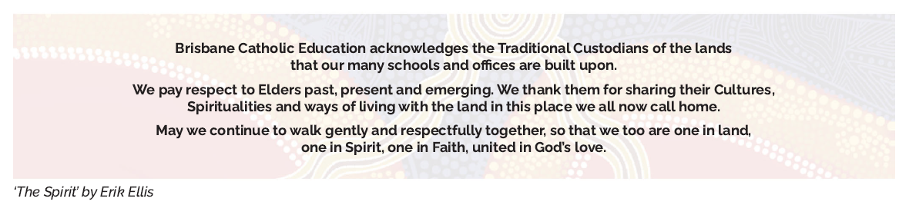  - report all concerns of possible abuse or exploitation towards students and adults-at-risk.  ‘The Spirit’ by Eric Ellis | - support the purpose and mission of the Catholic Church and Catholic schools.  - embody the BCE vison, mission, and values.  - promote an inclusive, supportive, and respectful culture. | - promote a workplace culture that aims to prevent injury and fosters wellbeing.  - comply with reasonable health and safety instructions.  - identify and promptly report safety concerns, injuries and issues.  - prioritise your own health and wellbeing and support that of colleagues.

