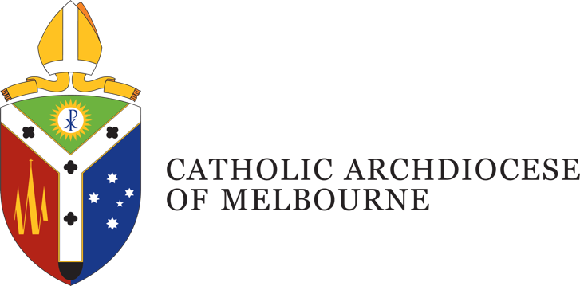

Position Description
Title: Formation Specialist: Sacraments & Liturgy
Department: Proclaim: Office for Mission Renewal
Location: East Melbourne
Employment Status: Full-time
Reports to: Formation Coordinator
Number of direct reports: nil

Position Purpose
The Formation Specialist: Sacraments & Liturgy will lead the exploration, identification, curation, and implementation of high-quality resources and formation initiatives to equip and resource parish leaders across the Archdiocese of Melbourne in relation to the sacraments and liturgy.
Grounded in a discipleship-based approach, this role will assist parishes and communities in delivering liturgical and sacramental formation for children, families, and adults preparing for full initiation into the life of the Church. Working closely with parish leaders, sacramental teams, and school partners, this role will also ensure that sacramental preparation and liturgical formation is both theologically sound and pastorally effective.
This role requires strong pastoral sensitivity to support parishes in identifying and responding to opportunities for evangelisation, discipleship and formation through sacramental preparation. This includes equipping parish teams to see these moments not only as catechetical events, but as key points of encounter with Christ for families and individuals

Department Overview
Proclaim: Office for Mission Renewal was established in early 2020 to support the life of the Archdiocese of Melbourne in our aim to strive for ‘the missionary option’ in all we do. In responding to this call, we heed Pope Francis’ words in Evangelii Gaudium to seek 'a missionary impulse capable of transforming everything, so that the Church’s customs, ways of doing things, times and schedules, language and structures can be suitably channelled for the evangelisation of today’s world'. (§27)
The Proclaim team is at the service of parish communities within the Archdiocese, offering strategies, resources and support. The team is divided into three domain areas that direct our efforts:
Animation – focussed on parish renewal with a team of animation consultants who work directly in support of clergy and parish leadership teams. The animation team focus on growing communities of faith that are vital, vibrant and viable.
Discipleship – support our parishes to grow a culture of discipleship of encountering Jesus Christ, engaging more deeply in a life of faith, and embarking on mission with a particular focus on youth and young adults, campus ministry and family accompaniment.
Formation – equipping people to be formed and form others through the Bethany Way and including the development of formation resources that supports the life of our parishes.

Organisational Description
Presided over by the Archbishop of Melbourne, the Archdiocese comprises around 1.1 million Catholics, and is the largest Archdiocese in Australia with a wide variety of people, cultures and ministries, providing services and support including pastoral, educational, social welfare and administrative support.
Under the guidance of four key priorities outlined by the Archbishop, the works and activities of the Archdiocese are oriented towards a missionary focus to address the ongoing needs of: Local Communities; Families; Youth and Young Adults; and the Poor and the Broken.
This is achieved through a pro-active engagement in the sharing of Mission; a reaching out in Gospel boldness; operating in an agile and responsive mindset; identifying and embracing what is fruit bearing in our works; understanding the outward focus and call of being missionary disciples; and being mindful of good stewarding in terms of time, talent and gifts.

Key Accountabilities
In this role, you will:
- Curate accessible, theologically rich, and pastorally engaging resources for the Sacraments of Initiation and liturgical worship.
- Design and deliver diocesan-wide workshops, seminars, formation and training for parish leaders, sacramental coordinators, catechists, and volunteers.
- Provide formation, consultation and expertise to parishes seeking to renew or establish effective sacramental pathways.
- Collaborate with Catholic Education and parish-school networks to identify opportunities for integrated and consistent sacramental preparation processes.
- Work in alignment with the Archdiocesan foundational documents on formation and discipleship.
- Evaluate and adapt resources and strategies based on parish feedback and changing community needs.
- Contribute to a diocesan-wide strategy for life-long formation and discipleship beyond the sacraments.
- Support the delivery of liturgies within the purview of the Proclaim Team .
- Ensure cultural and pastoral sensitivity in all resources and implementation methods.
- Actively contribute to Formation team initiatives and collaborate across other Proclaim initiatives and domain areas as required.

Job Competencies – (skills)
- Experience in catechesis, sacramental and/or liturgical preparation in a parish, school or diocesan setting
- Strong facilitation, presentation, and adult learning design skills
- Demonstrated capacity to identify and curate faith formation resources across diverse age groups
- Familiarity with contemporary Church documents on evangelisation, formation, liturgy and catechesis
- Ability to manage multiple projects and respond flexibly to evolving needs
- A deep understanding of, and commitment to, the teachings of the Catholic Church.

Personal Competencies – (attributes)
- Excellent interpersonal and communication skills, with the ability to relate effectively to clergy, lay leaders, and families.
- A deep commitment to the mission of the Catholic Church, liturgical and sacramental life
- Passion for evangelisation, catechesis, and forming missionary disciples
- Collaborative, relational, and culturally aware
- Confident in working within the complexities of parish life and Church structures
- Resilient, proactive, and innovative in pioneering new approaches
- Ability to work collaboratively within and across departments, agencies, and ministries of the Catholic Archdiocese of Melbourne

Essential Requirements
- Tertiary qualifications (or currently undertaking) in theology, religious education or a similar discipline.
- National Police Record Check (essential).
- Working with Children Check (essential).

Position Description Acknowledgement
By signing my contract, I acknowledge that I have received, reviewed and fully understand the position description for Click or tap here to enter text. I further understand that I am responsible for the satisfactory execution of the essential functions described therein, under any and all conditions as described.

Employee Name: Click or tap here to enter text. Date: Click or tap to enter a date.

Employee Signature: _________________________________________

